**INTERNATIONAL UNION OF NOTARIES (UINL)**

Dialogue between Legal Systems

“The notary – a bridge between legal systems”

(Conference facilitated by the Law Society of Scotland)

**5th September 2025**

**Edinburgh International Conference Centre, The Exchange, Edinburgh, EH3 8EE, Scotland**

**REGISTRATION FORM**

Please fill in the form and email to [uinldialogue@cheeswrights.com](mailto:uinldialogue@cheeswrights.com) and copy to [uinl@uinl.org](mailto:uinl@uinl.org) **before 31st July 2025**

**Please note that registration is mandatory**

1. **IDENTIFICATION**

|  |
| --- |
| Participant: Mr. Ms/Mrs |
| Last Name: |
| First Name: |
| Address: |
| Country: |
| Notary Chamber/Association of: |
| Telephone: |
| E-mail: |

1. **REGISTRATION FEES**

|  |  |
| --- | --- |
| Charge for each participant | £300 |
| Charge for gala dinner at the National Museum of Scotland  * Charge for accompanying person at dinner | £125  £125 |
| Total amount: | £ |

|  |
| --- |
| **PAYMENT TO BE MADE USING FOLLOWING BANK DETAILS:**  Account Name: Cheeswrights LLP Account Number: 50829025  Sort code: 16-01-01  IBAN: GB60RBOS16010150829025 SWIFT/BIC code: RBOSGB2L  Name of the Bank: The Royal Bank Of Scotland  Address of the Bank: Chatham (Shipping) Waterside Court, Chatham Maritime, Chatham, Kent, ME4 4RT, UK  **PLEASE QUOTE LAST NAME OF THE PARTICIPANT AS REFERENCE FOR PAYMENT** |

1. **SPECIAL REQUESTS (diets, allergies, disabilities, other)**

……………………………………………………………………….

1. **\* NAME OF ACCOMPANYING PERSON:**

……………………………………………………………………….

1. **SUGGESTED ACCOMMODATION**

[Sheraton Grand Hotel & Spa, Edinburgh](https://www.marriott.com/en-gb/hotels/edisi-sheraton-grand-hotel-and-spa-edinburgh/overview/)

[Hampton by Hilton Edinburgh West End](https://www.hilton.com/en/hotels/edifbhx-hampton-edinburgh-west-end/)

[Leonardo Hotel Edinburgh Haymarket | Leonardo Hotels](https://www.leonardo-hotels.com/edinburgh/leonardo-hotel-edinburgh-haymarket)

[Central hotel Edinburgh: voco Edinburgh-Haymarket](https://www.ihg.com/voco/hotels/us/en/edinburgh/edits/hoteldetail?cm_mmc=GoogleMaps-_-VX-_-GB-_-EDITS)

A further list of hotels can be found [here.](https://www.visitscotland.com/info/accommodation/search-results?prodtypes=acco&avail=off&locplace=4161&loc=Edinburgh&locprox=0&name&cat=boutquhotl&cat=budgethotel&cat=countryhoushotl&cat=hotel&cat=intresorthotel&cat=luxuryhotl&cat=metrohotel&cat=smallhotel&cat=spahotel&cat=townhousehotel)

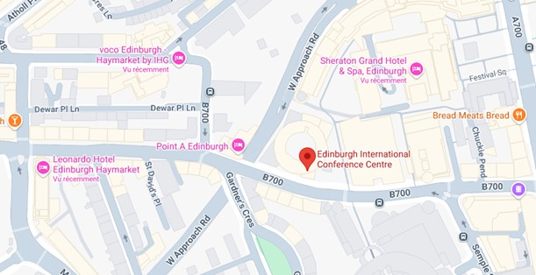*There will be a daytime program for accompanying persons depending on numbers attending, further details to follow.